AIAC LAB ASSIGNMENT 4.1
Name : D.Shruthi
Batch : 31
Ht No: 2303A52407
Zero-Shot Prompting
Prompt: #write a python program that classifies the text spam or not spam
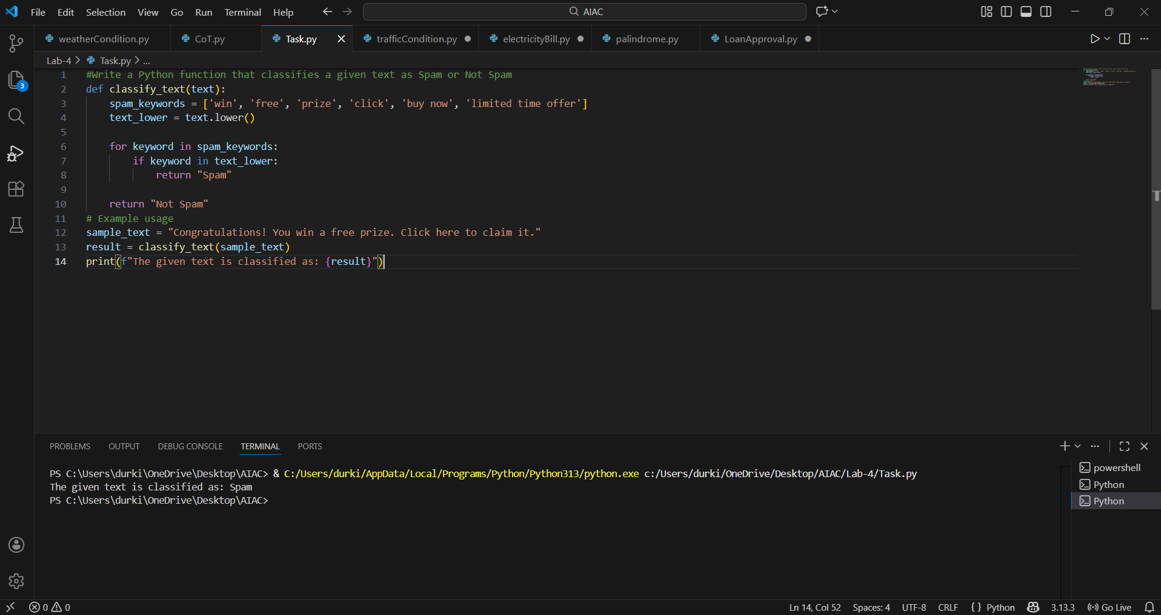
This program classifies a given text as Spam or Not Spam by checking for predefined spam-related keywords.
It converts the input text to lowercase and uses regular expressions to accurately detect spam words.
If any spam keyword is found, the text is labeled Spam; otherwise, it is labeled Not Spam

One-Shot Prompting
Prompt: Write a python code to detect emotion of a sentence
example input : "I am very happy today"
example output: "happy"

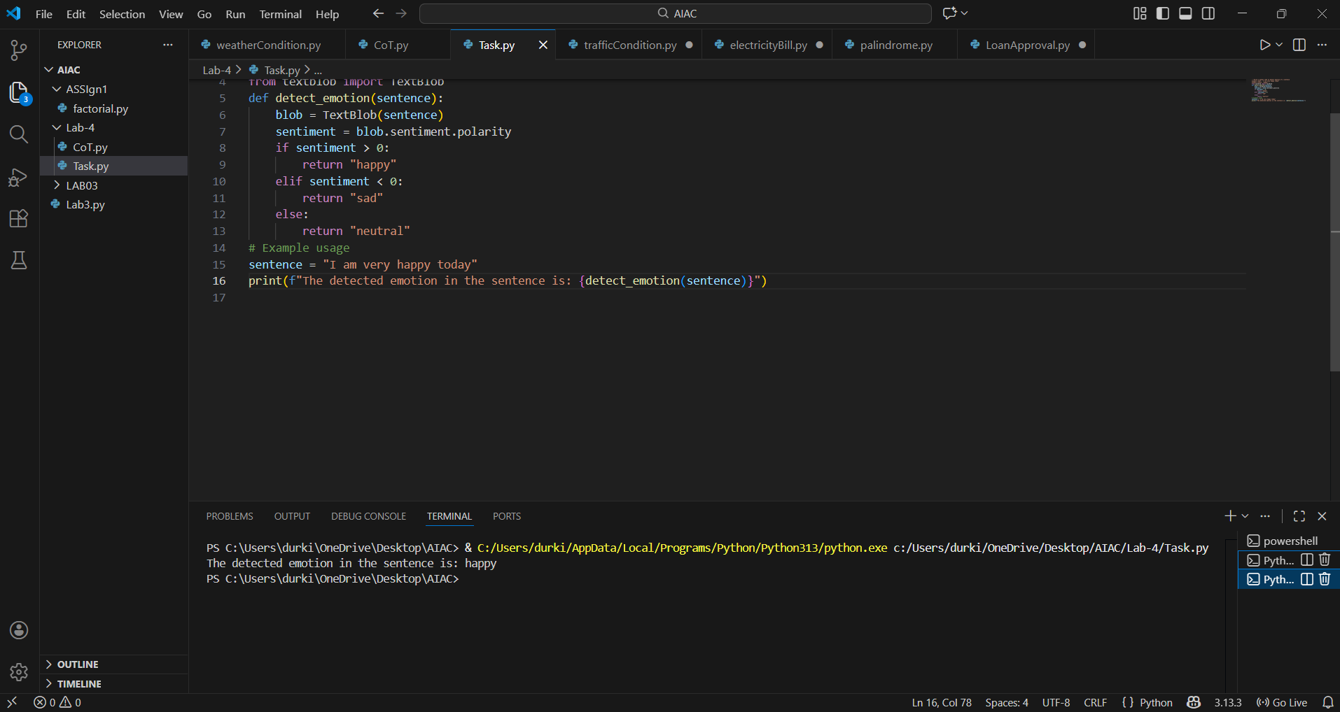
This program detects the emotion expressed in a given sentence by matching keywords related to emotions.
It analyzes the input text and compares it with predefined emotion words such as happy, sad, or angry.
Based on the match, it identifies and prints the corresponding emotion.
If no emotion is detected, a default response can be shown.

Few-Shot Prompting
Prompt: predict the student grades based on marks
Example:
90–100 → A
80–89 → B
70–79 → C
60–69 → D
Below 60 → F

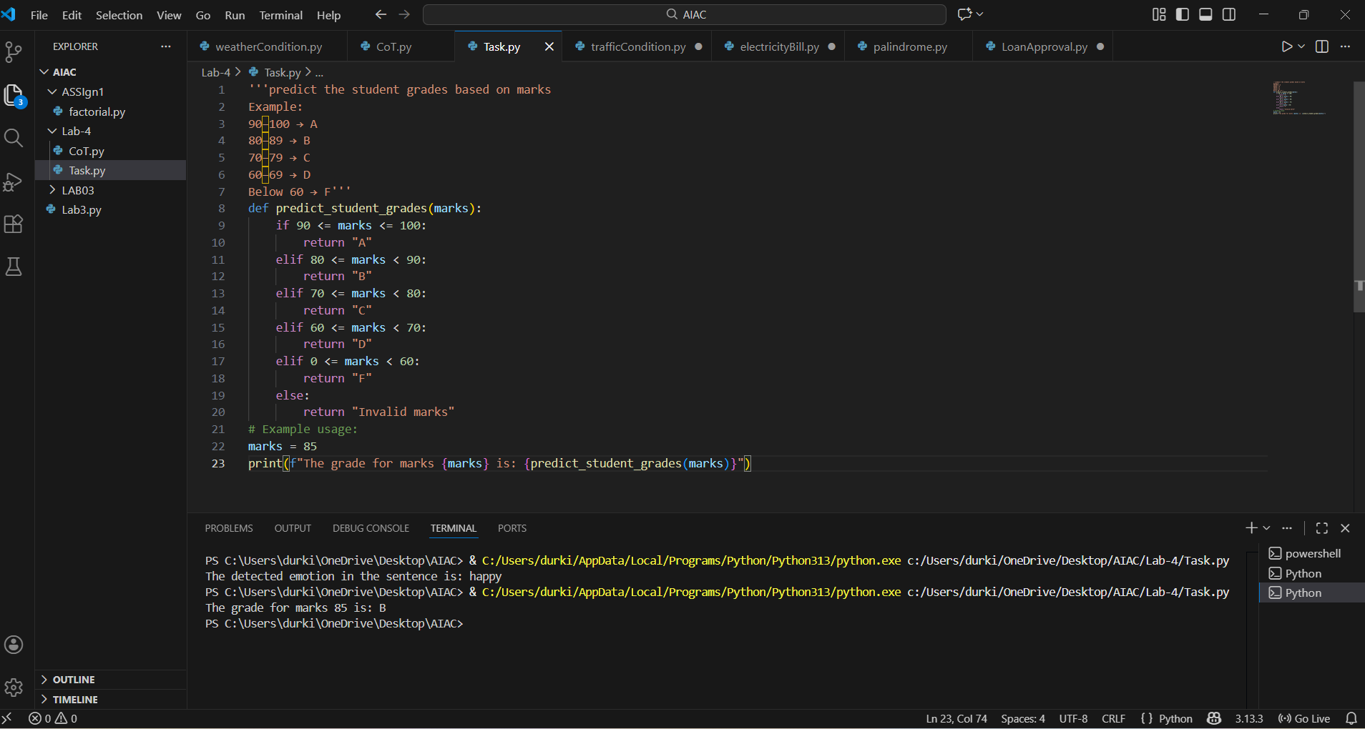
This program predicts a student’s grade based on the marks entered by the user.
It uses conditional statements to compare marks with predefined grade ranges.
Each range corresponds to a grade from A to F.
The final grade is displayed according to the student’s score.

Multi-Shot Prompting
Prompt: predict the indian zodiac sign based on birth month,take input from user
March → Mesha
April → Vrishabha
May → Mithuna
June → Karka
July → Simha
August → Kanya
September → Tula
October → Vrischika
November → Dhanu
December → Makara
January → Kumbha
February → Meena

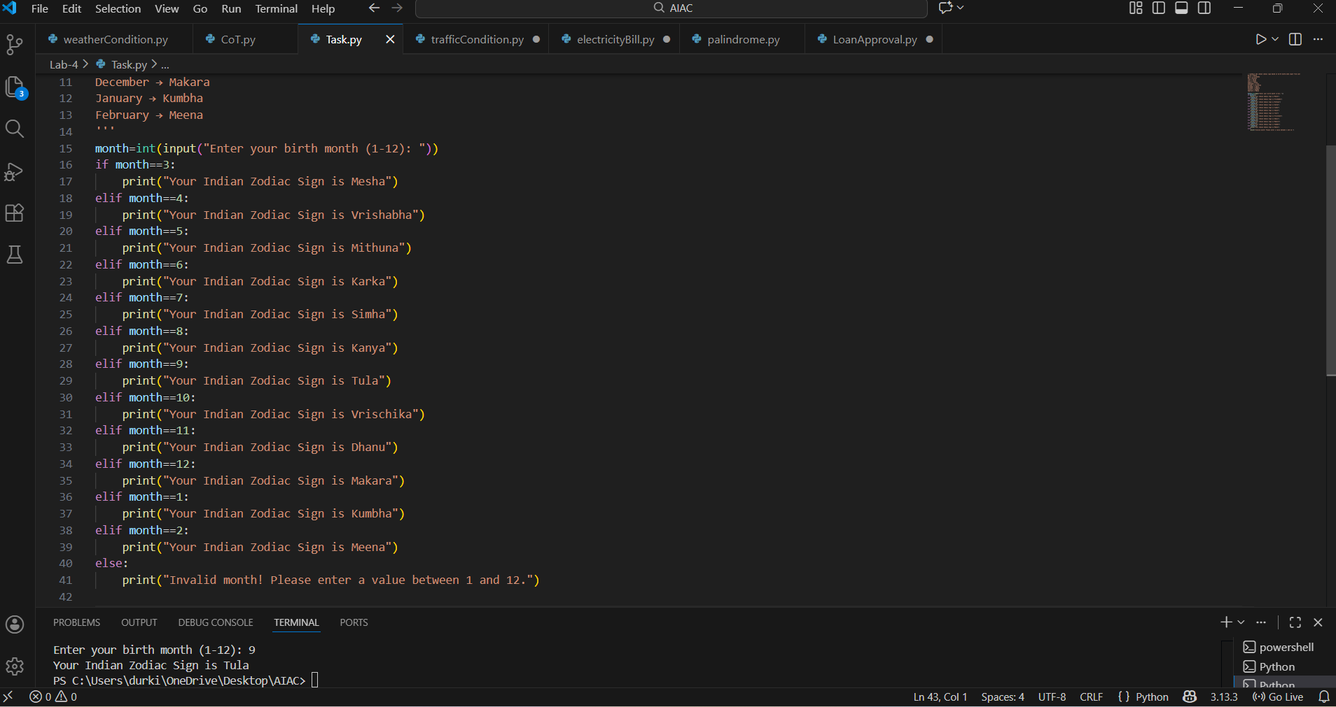
This program predicts the Indian zodiac sign based on the user’s birth month.
It takes the month as input and matches it with predefined zodiac mappings.
Conditional logic is used to identify the correct zodiac sign.
The corresponding zodiac sign is then displayed to the user.

Result Analysis Based on Marks
Prompt:
take input from user
check the pass and fail criteriaa
if pass print "pass" else print "fail"

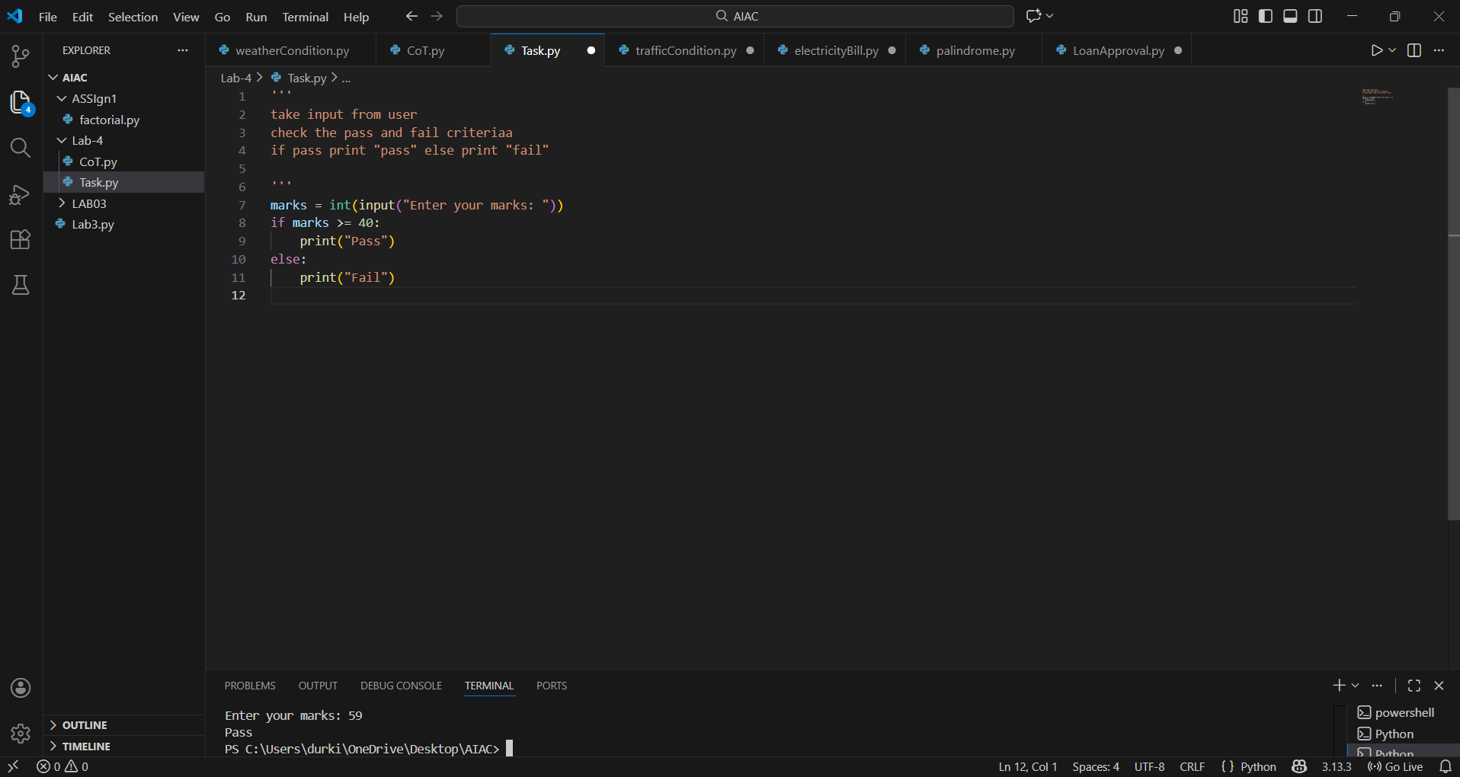
This program checks whether a student has passed or failed based on the given marks.
It takes marks as input from the user.
If the marks meet the pass criteria, it prints “Pass”.
Otherwise, it prints “Fail”.
Voting Eligibility Check (Chain-of-Thought Prompting)
Prompt: take input from user
check the voting elgibility
if yes print eligible otherwise not eligible
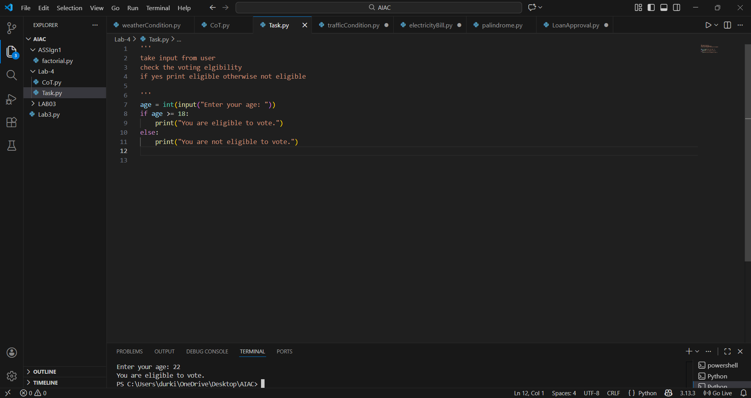This program checks whether a person is eligible to vote based on age.
It takes the user’s age as input and applies the eligibility condition.
If the age is 18 or above, the user is marked as eligible.
Otherwise, the program displays not eligible.
Prompt Chaining (String Processing – Palindrome Names)
Prompt: 1. Given the following list of student names, check palindrome or not
Names: ["madam", "level", "rahul", "radar","aka"]
2. Print only those names which are palindrome from the given list
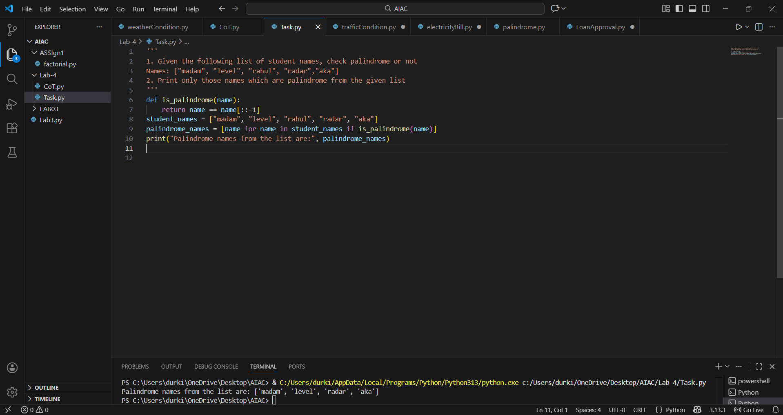
This program checks a list of student names to identify palindromes.
A palindrome is a word that reads the same forward and backward.
Each name is compared with its reverse to check the condition.
Only palindrome names are selected from the list.

Prompt Chaining (String Processing – Word Length Analysis)
Prompt: 1. From the previous results, display only the names that are palindromes.
2. Using the generated list of words, calculate the length of each word.
3. Using the word lengths from the previous step, classify each word as:
Short if length < 5
Long if length >= 5
Display each word with its classification

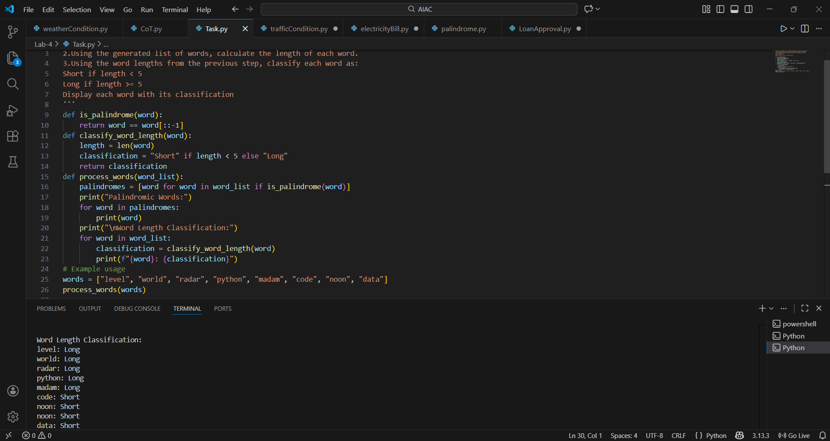
This program works on the list of palindrome names obtained earlier.
It calculates the length of each word in the list.
Based on the length, words are classified as Short or Long.
The final output displays each word along with its classification.

